Azure Storage

Three types:

1)Storage for Virtual Machine(Like Disks, and Files)

2) Unstructured data(blobs , data lakes)

3)Structured data(like tables , azure SQL DB,cosmos DB)

------------------------------------------------------------------------------------

**Azure Storage - Storage Account Types**

1)

**Blob storage- Unstructured data, such as text, or binary data.**

-----

**2)files**

Azure files enables you to **set up highly available network files shares** that can be accessed by using Standard server message block **(SMB) protocol from anywhere in the world**.

3)**Tables:**

Allows you to store **structured data (NoSql) in the cloud** providing a key attribute store with schemaless design.

4)**Queues:**

The azure queues service is **used to store and retrieve messages.** Queue messages can be upto 64kb size. And queues can contain millions of messages.

# Azure Storage - Storage Account Performance

----------------------------------

# Azure Storage - Storage Account Kinds

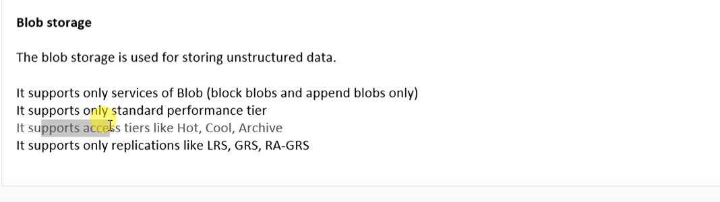

-------------------------------------------

# Azure Storage - Storage Access Tiers

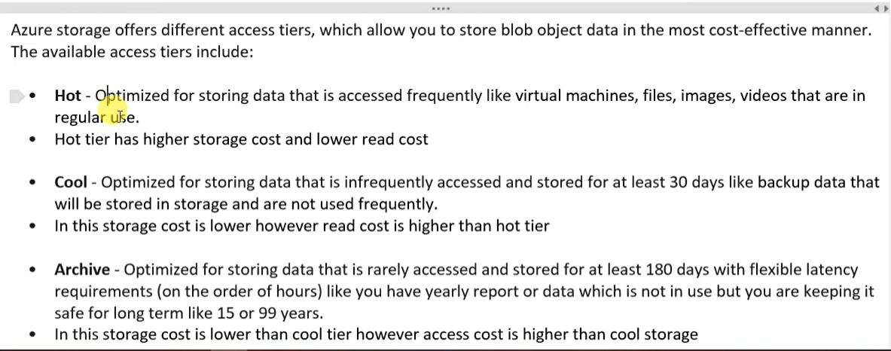

1. **Hot tier**: - use when we are accessing data frequently. Like daily. It has higher storage costs and lower read cost.
2. **Cool tier:** use when we ae accessing the data infrequently, like on a weekly, monthly basis.it has lower storage cost but higher read cost.
3. **Archive**: when we rarely want to use the data, we use archive tier. So for example some of the critical domain like banking, if they want to use 15 years old data they can use this tier. It has lower storage cost than cool tier but access cost is higher.

# Azure Storage - Blob Storage Container &

Storage replication:

# Azure Storage - Lab Blob Storage

# 

Whenever we want to create a blob storage firstly will have to create a container (in basic term it is a folder and inside that folder we will keep everything)

<https://youtu.be/phVRFDBcpMk?si=eSnEbRnx5OG5aTAm>

Three options you will get:

Private (in this you will not be able to access the url or anything else over the internet.)

Blob (anonymous read access for blobs only)

Container (anonymous read access for containers and blobs.)

# Azure Storage - Lab Access Tier, Access Key & SAS URI

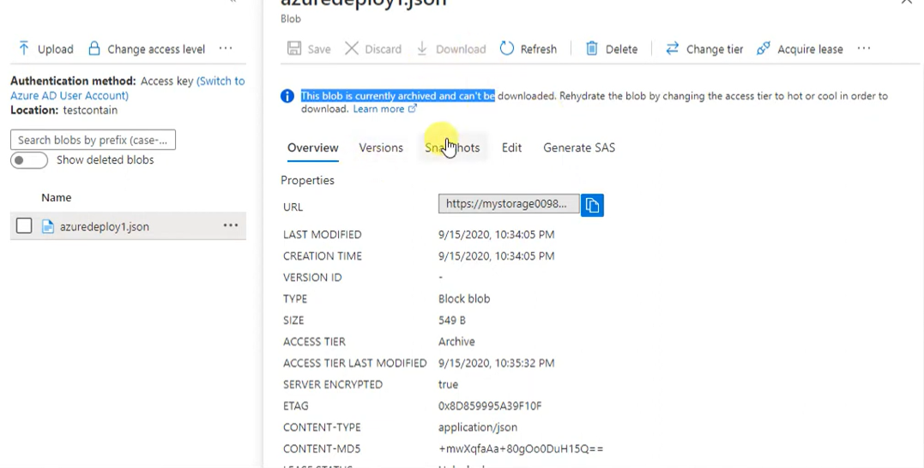

Whenever you will give archive as access tier it will have restrictions that can’t be downloaded. So, you will have to change the access level to hot/cool firstly by changing the tier.

Edit option will also be not there it will deny because we that has gone to archive.

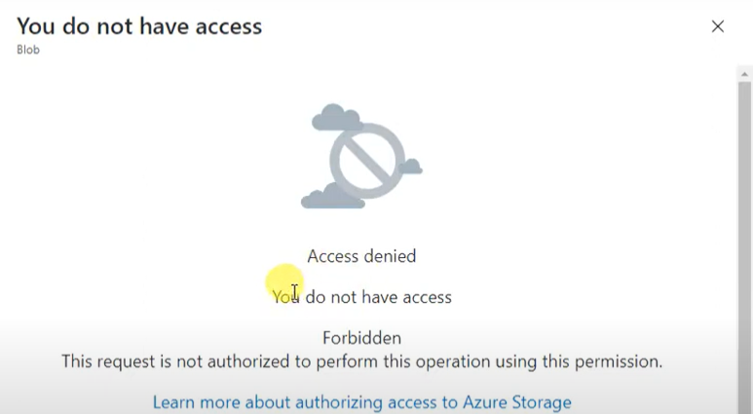

And whenever you want to change tier/rehydrate it will take hours to complete.

**ACCESS KEYS:**

Suppose your application is linked with the storage account and has to be opened you can try to open by the given keys(1,2) if hacker hacks the key1 then you will have to access it by key2 and immediately change the key1 (by regenerating).

In storage explorer you will have to add the storage account and give the keys while adding. Then only you will be able to see. Refer above image.

**shared access signature (SAS):** It creates temporary URL to access.

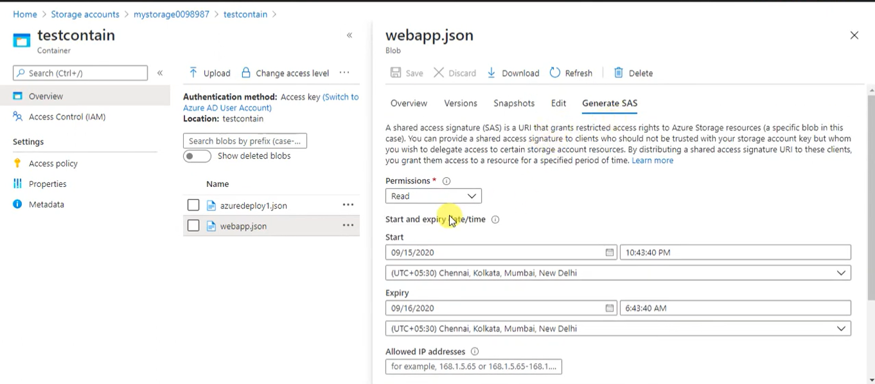

A shared access signature (SAS) is a URI that grants restricted access rights to Azure Storage resources. You can provide a shared access signature to clients who should not be trusted with your storage account key but whom you wish to delegate access to certain storage account resources. By distributing a shared access signature URI to these clients, you grant them access to a resource for a specified period of time.

An account-level SAS can delegate access to multiple storage services (i.e. blob, file, queue, table). Note that stored access policies are currently not supported for an account-level SAS.

# Azure Storage - Lab File Storage

So basically, it is used when we are migrating the data/server from on prem to azure.

Similar like container we have to create a file share (a folder in simple words) and inside that we can store the files.

Suppose if we want to give access to the server we can create or map a network drive, for that post 445, SMb PORT should be allowed from your PC. The user can share/store the data in the drive mapped.

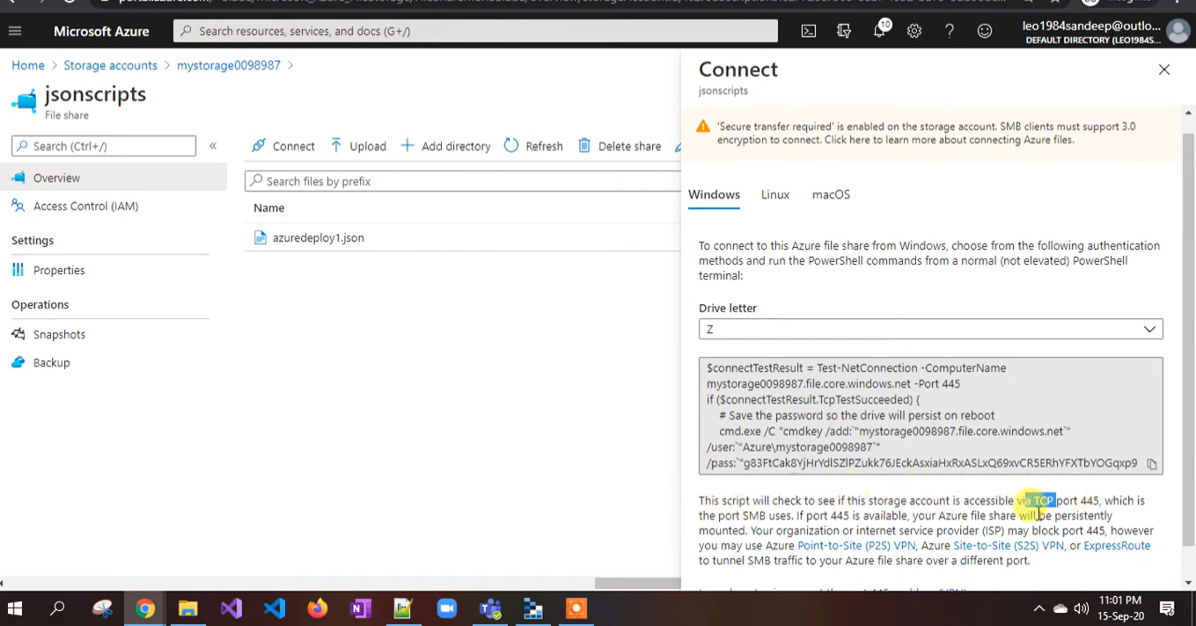

run the script in relevant OS

Network drive will be mapped once the script is successfully run.